**Web Development 2 Assignment**

C14337041

**Code used in the pages:**

Most of the pages use html to provide content for the page and then use php to perform all data validation and database work. Css is also used to style the page to make them look aesthetically pleasing. All files have a .php extension to allow flexibility across the pages (apart from the CSS files).

**Pages:**

*General Pages:* Included in each page is 3 files called Header.php, Footer.php and Welcome.php. Each of these files has a different task associated with them. The header file displays the nav bar (links to Homepage.php, Books.php and ContactUs.php) and the image bar across all pages whereas the footer page displays the footer bar at the bottom of the screen. Embedded in the header file is a welcome file which displays details up the top right of the screen. If the user is not login, there will be a link to a login screen and a sign up screen. However, if the user is logged in, it displays a “welcome ‘username’” message and also a link to a logout page. A page called DB.php is also included in files to allow the user to establish a connection to the database.

*Homepage.php:* This is the main page of the website. It has an opening hour’s timetable to add some content to the page

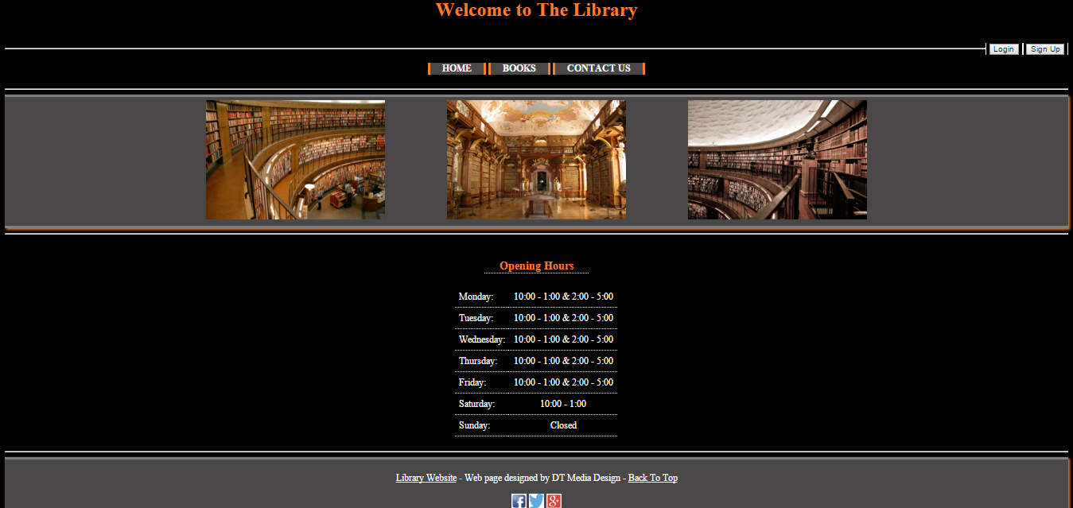

*Books.php:* This is the main page with regards to the search functionality of the website. Upon clicking on the page in the nav bar, you will be greeted with 3 different options, provided the user is signed in. If not, the user will be presented with the option to sign in or sign up to the website. One the user has successfully logged in they can return to the page and choose to search using a book name and/or Author, a category and finally view all reserved books in the library. The user will be brought to one of the pages depending on which option they select. SearchAut_Tit.php, SearchCat.php or ViewReserved.php

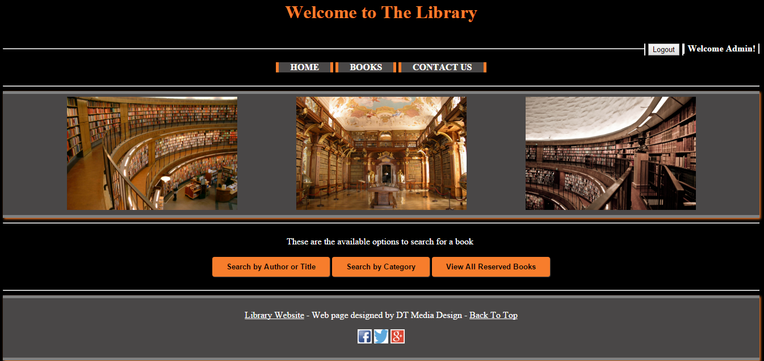

*ContactUs.php:* This page was added in as a filler page to add more pages to the nav bar. It contains a simple form and an information paragraph about the website and has no real functionality except to add in an extra page.

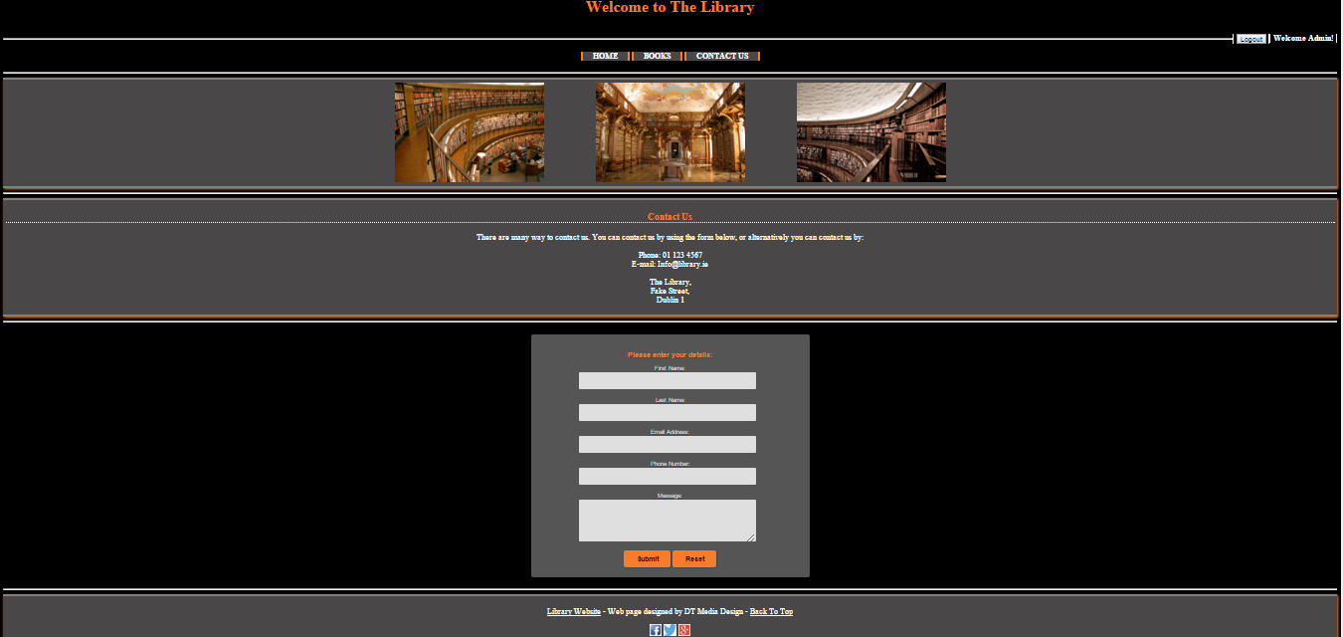

*Login.php:* This page is linked to from the welcome.php page and also from and page which requires the user to be signed in. It features a simple form where the user enters their username and password and then has them checked against the database to ensure they are correct. If they match, the user can continue and is redirected back to the homepage, however errors are displayed if the user has problems logging in.

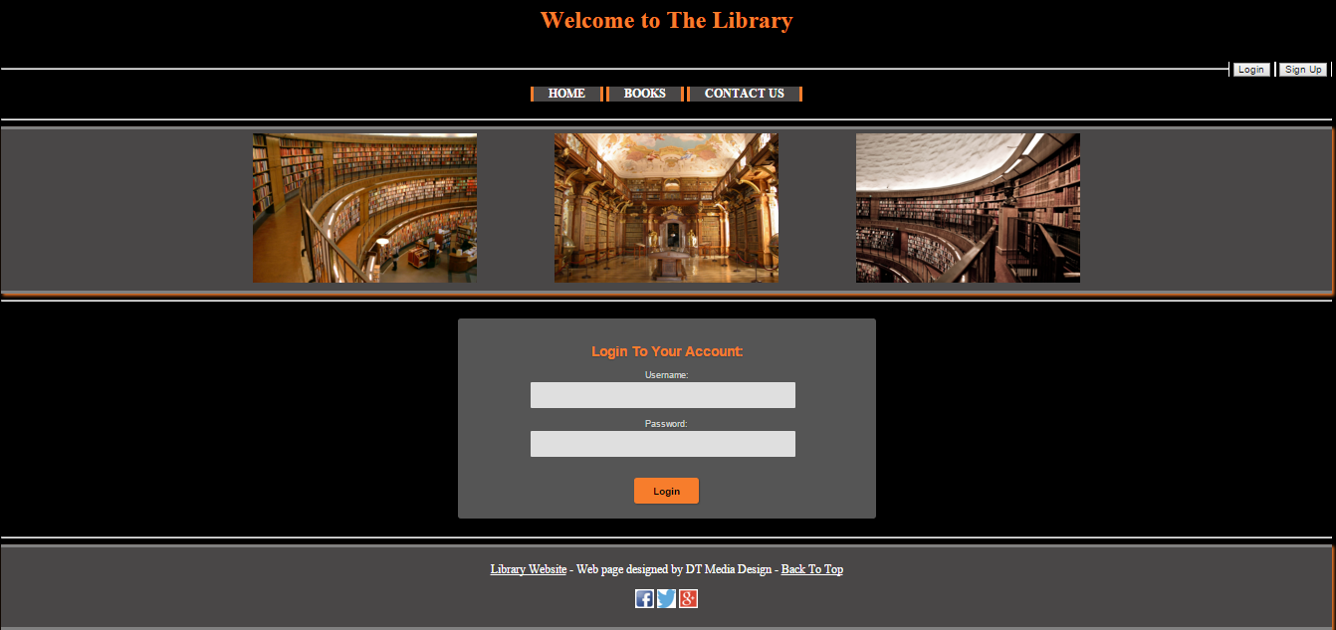

*SignUp.php:* This page is linked to from the welcome.php page and also from and page which requires the user to be signed in. It features a simple form where the user enters their information and then has the information checked to ensure it is correct and matches the right format. If they match, the user can continue and can now log in, however errors are displayed if the user has problems signing up.

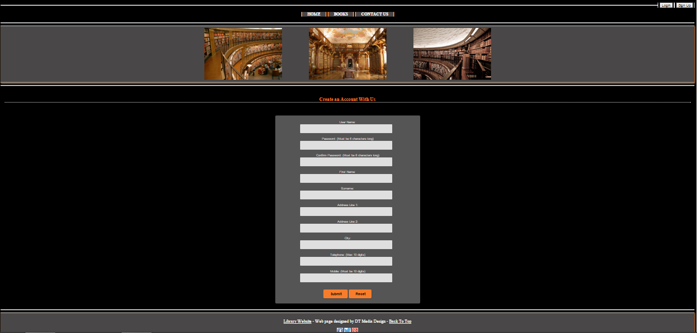

*Search”Type”.php:* There are multiple search pages used throughout the website. However, they all do similar things, but just search for different things. One search file search’s by category and another searches by book title and/or author. Both pages will link to the relevant display pages and display the user with information that matches their search criteria. The category search populates a dropdown menu with options from the database, whereas the author and/or title search uses a form to get the information from the user.

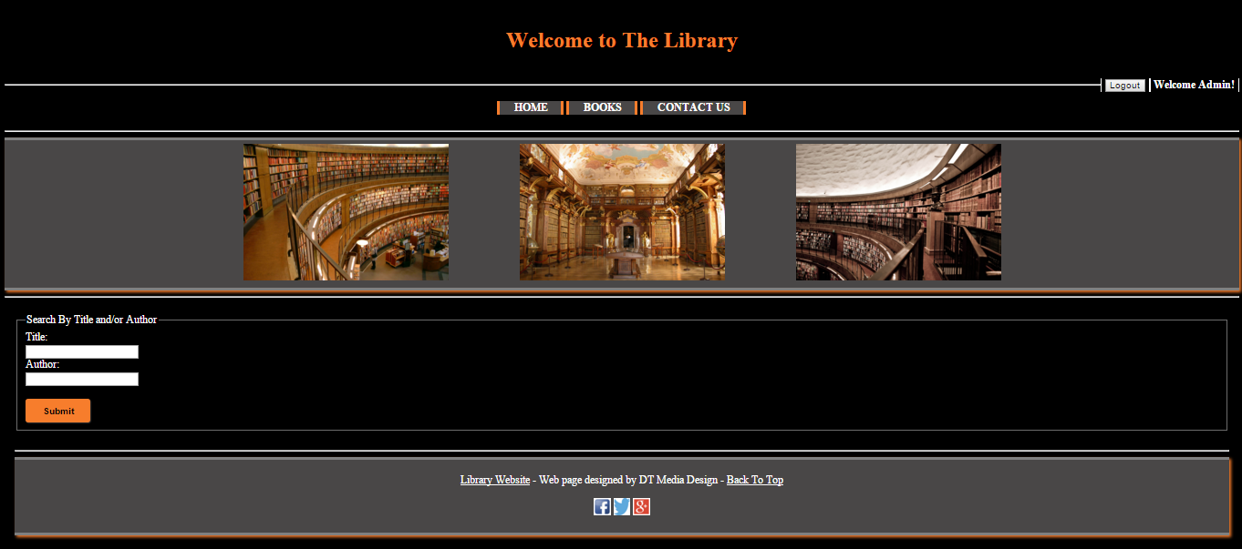

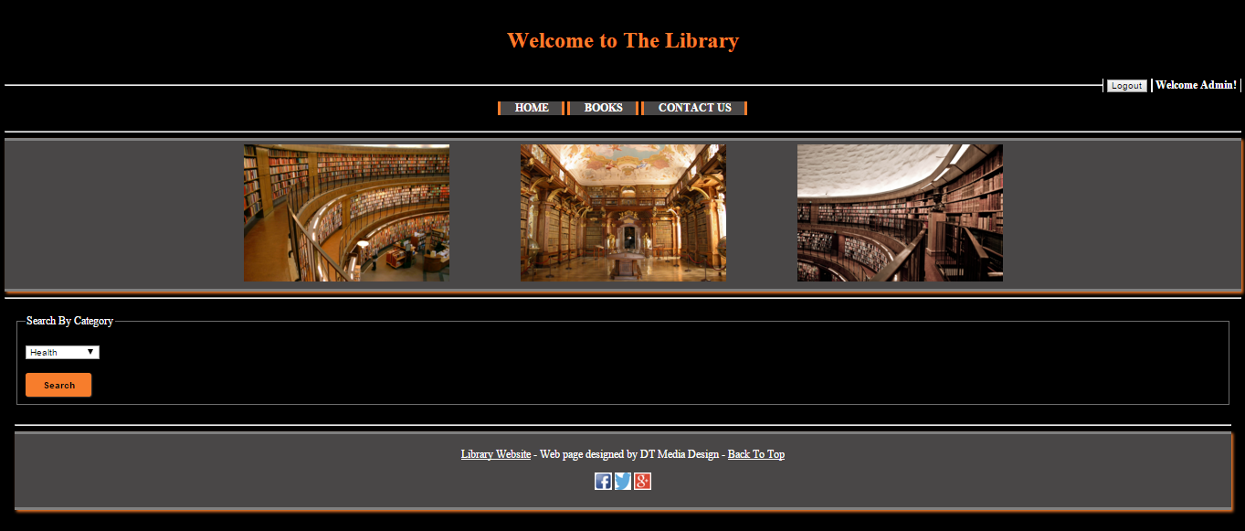

*Display”Type”.php:* Similar to the search pages, there is multiple display pages used in the website. Again, all do similar things, but just display different types of data as provided by the relevant search page. If the user search’s by a category, a list of data based on categories will be displayed and vice versa. The display pages will display no more than 5 lines of data per page and will allow the user to click throw different pages e.g page1, page2…… to see more data. There is also an option beside each book to reserve (links to Reserve.php) it If it is not already reserved or to unreserve (links to UnReserve.php) the book if it is reserved by the current user, otherwise it will tell the user the book is reserved by another user.

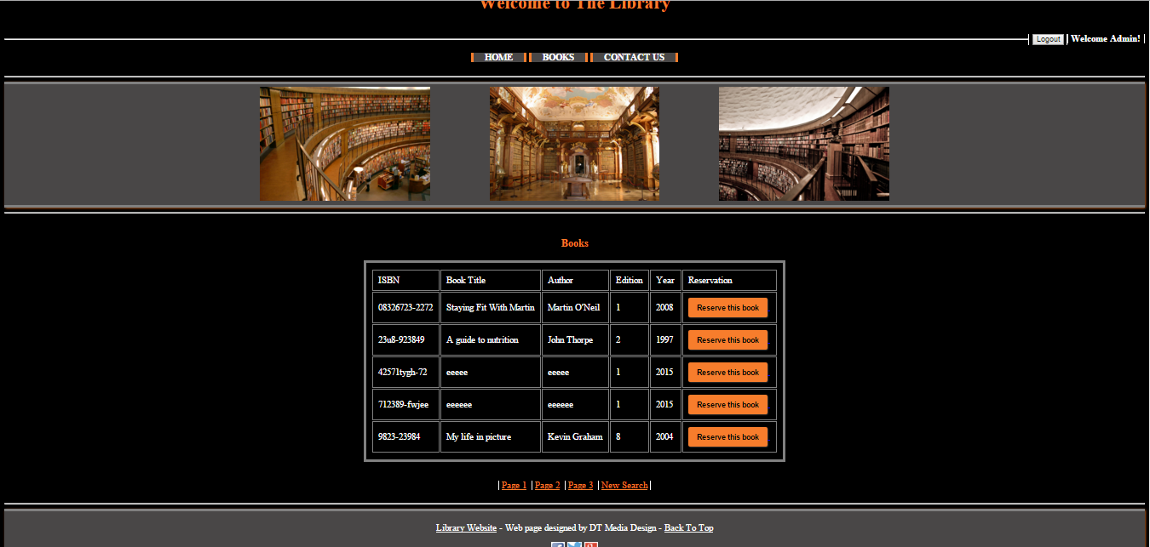

*ViewReserved.php:* This is the last option on the Books.php page. It allow the user to view all books that are currently reserved and gives the user the option to un reserve a certain book if they themselves have already reserved it (re directs to UnReserve.php) otherwise it will tell the user that the book has been reserved by another user.

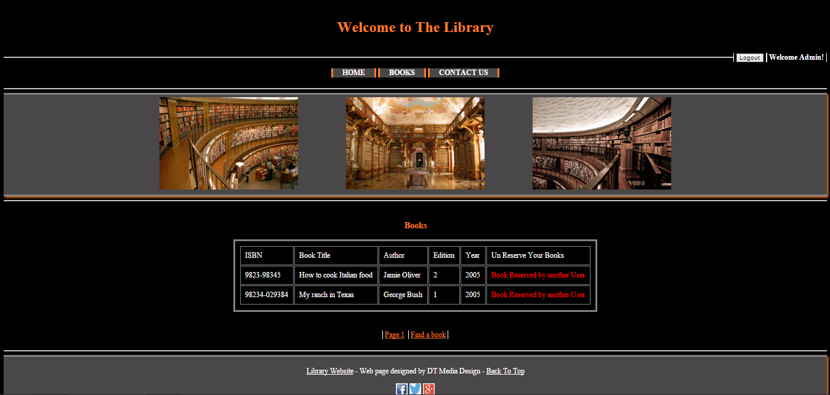

*Reserve.php and UnReserve.php:* These pages do the opposite from each other but use the same method. They both receive the ISBN of the book over the URL and then use the get method to put to info into a variable. Then they both update the databases accordingly (I.ie add or delete a reservation) and provide the user with an error or success message depending on the result.

**List of all pages included:**

3 style sheets in folder called “StyleSheets”, 6 pictures in a folder called “Pictures” and 19 .php files. All listed below.

